



**YEAR 12 CHEMISTRY**

**TEST 4**

**Organic Chemistry Question/Answer Booklet**

**STUDENT NAME**

**TEACHER**

**Recommended time: 55 minutes**

**Materials provided for this test**

* **Test booklet**
* **Multiple-choice Answer sheet**
* **Chemistry Data Sheet**

**STRUCTURE OF THIS TEST**

**Section One: 15 Multiple- choice questions 15 marks**

**Section two: 7 Short answer questions 40 marks**

**Section three: 1 Extended answer question 5 marks**

**Section one: Multiple-choice (15 marks)**

Answer the questions on the multiple-choice answer sheet provided.

1. The structural formula for cyclopentane is given below:



Which of the following compounds is the correctly named isomer of cyclopentane?

1. 2-methylbutane.
2. 2,3 - dimethylpropane.
3. Pent-2-ene.
4. Pent-3-ene.

2. Which of the following compounds is likely to be the least soluble in water?

1. CH3CH2CH2C

(b) CH3CHOHCH3

(c) CH3CH2COCH3

(d) CH3CH2CH2CH3

3. Consider this compound, an unsaturated aldehyde, whose systematic name ends with-enal.

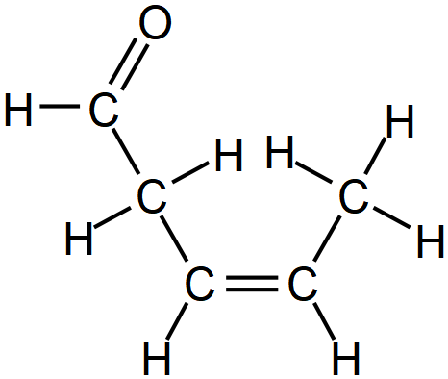

Its correct IUPAC name is:

1. cis-pent-3-enal
2. trans-pent-3-enal
3. cis-pent-2-enal
4. trans-pent-2-enal

4. Many foods use artificial fruit flavorings made from synthetic esters. Esters are usually prepared in the laboratory by the reaction of

1. a carboxylic acid and an aldehyde.
2. an aldehyde and a primary alcohol.
3. an aldehyde and a carboxylic acid.
4. an alcohol and a carboxylic acid.

5. Which compound would have the highest boiling point?

(a) CH3CH2OH

(b) CH3COOH

(c) CH3COCH3

(d) CH3CH = CH2.

6. Which of the following organic compounds would most likely act as a base in water?

1. CH3CH2C
2. CH3CH2OH
3. CH3CONH2
4. CH3CH2NH2

7. Which of the following substances does **not** demonstrate geometric *(cis/trans)*isomerism?

1. but-2-ene
2. pent-2-ene
3. 1,3-dichloropropene
4. 1-chloro-2-methylpropene

8. Which of the pairs of compounds below could be used to make the following molecule?

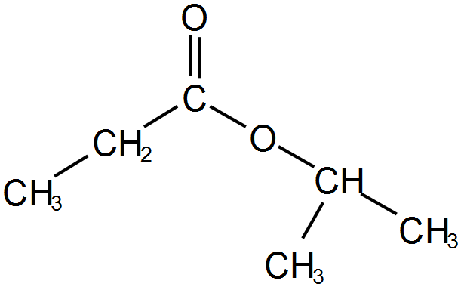

1. Propanoic acid and propan-2-ol
2. Propanoic acid and 2-methylpropan-2-ol
3. Ethanoic acid and propan-2-ol
4. Ethanoic acid and propan-1-ol

9. Ethanol is removed from the body by reaction with the enzyme alcohol dehydrogenase (ADH). In fact, ADH can oxidise any alcohol. ADH, like all enzymes, is very specific and will not catalyse any other reaction. However, the product of the ADH reaction with an alcohol may undergo further reaction with other enzymes

The reaction of butan-2-ol with ADH would produce

1. butanal
2. butan-2-one
3. butanoic acid
4. 2-methylpropan-2-one

10. Which of the following reactants are capable of forming a condensation polymer under suitable conditions?







(b)



(c)



(d)

11. In a series of experiments the following observations were made about a colourless liquid.

|  |  |
| --- | --- |
| **Experiment** | **Observation** |
| Liquid was added to potassium dichromate solution | No visible reaction |
| Liquid was added to sodium metal | Colourless, odourless gas evolved, silvery solid dissolved |
| Liquid was added to ethanol and heated with concentrated sulfuric acid | Fruity smell produced |

Which one of the following substances would produce all of these observations?

(a) 2-methylbutan-2-ol

(b) butanoic acid

(c) butan-2-ol

1. butanone

12. Which of the following have the same molecular formula as methyl propanoate?

1. methypropan-1-ol
2. ethyl ethanoate
3. butanoic acid
4. butan-2-one
5. methylpropanoic acid
6. (i), (ii) and (iii) only
7. (ii), (iii) and (iv) only
8. (iii), (iv) and (v) only
9. (ii), (iii) and (v) only

13. Which one of the following **cannot** be a product of the oxidation of CH3CH2CH2CH2OH?

(a) CH3CH2CH2CHO

(b) CH3CH2CH2COOH

(c) CH3COCH2CH3

(d) CO2

Question 14 refers to the structures shown **below**.

CH3CH2COCH3 CH3CH2CH2CHO CH3CHCOOH CH3CHOHCH2CH3

CH3

A B C D

14. Which of the following will react to form an ester?

(a) A and B

(b) C and D

1. A and C

(d) B and C

Question 15 refers to the structures **below**

15. Which of the following gives their increasing order of solubility in cycloheptane?







I

II

III

IV



(a) l ll lll lV

(b) l lll ll lV

(c) IV II lll l

(d) lV ll l lll

**This page has been left blank intentionally**

**Section 2: Short Answer.**  **(40 marks)**

Answer **all** questions. Write your answers in the spaces provided.

16. Complete the table below by giving a brief description of a chemical test that could be used

to distinguish between propan-2-one and propanal.

List the observations relating to the test for both propan-2-one and propanal.

|  |
| --- |
| Description of simple test. |
| Observations for propan-2-one |
| Observations for propanal |

(3 marks)

17. C4H8O has several isomers. Complete the table below by drawing the isomers. Show **all** of the H

atoms in your structures. Give the IUPAC name for the structures you have drawn.

(9 marks)

|  |  |  |
| --- | --- | --- |
| Two structural isomers that are both aldehydes |  |  |
| Names: |  |  |
| Two geometric isomers that are both alcohols |  |  |
|  | trans isomer | cis isomer |
| A straight chain saturated isomer that is not an aldehyde |  | |
| Name |  | |

18. The compound that is responsible for the odor of candy bananas is 3-methylbutylethanoate.

1. Draw the structure of 3-methylbutylethanoate. Show **all** of the H atoms in your structures.

(2 marks)

1. Draw and give the IUPAC names for the two compounds that can be used to synthesize this compound

(4 marks)

19. Undecylenic acid (C11H20O2) is an active ingredient in medications for skin infections, and is used to relieve itching, burning, and irritation associated with skin problems such as [athlete's foot](https://en.wikipedia.org/wiki/Athlete%27s_foot) and [ringworm](https://en.wikipedia.org/wiki/Ringworm).

1. It is a straight chain unsaturated carboxylic acid that is not able to form geometric isomers. Using this information draw the structural formula of this molecule showing all atoms and all bonds.

(2 marks)

1. Describe a simple test with observations that could be used to distinguish between undecylenic acid (C11H20O2) and [undecanoic acid](https://en.wikipedia.org/wiki/Undecanoic_acid) (C11H22O2) .

(3 marks)

20 Complete the table below by either naming the compound whose structural formula has been given or use the name to draw the structural formula of the compound.

Show **all** of the H atoms in your structures.

|  |  |
| --- | --- |
| Name | Structural formula |
| 3-methylpentan-2-amine |  |
|  |  |
|  |  |
| *cis*-4-methylpent-2-ene |  |
|  |  |

(5 marks)

21. A pure **straight chain** saturated compound with the molecular formula C5H10O is treated with acidified potassium permanganate.

1. Name and draw a possible structure of the compound that is oxidised by the

acidified potassium permanganate. The isolated product of this oxidation reaction will produce a solution with a pH < 7.

(2 marks)

1. Write the balanced redox equations for this reaction
   1. Oxidation half- equation:
   2. Reduction half-equation
   3. Overall balanced equation:

(5 marks)

22. A commonly used polymer is polyvinyl acetate (PVA) and as an [emulsion](https://en.wikipedia.org/wiki/Emulsion) in water is commonly referred to as wood glue. Paper and textiles often have coatings made of PVA and other ingredients to make them shiny.

Polyvinyl acetate is made from the monomer shown below



1. Draw three units in the polymer formed from this monomer.

(2 marks)

Polyethylene terephthalate is another frequently used polymer that is formed by combining two monomers: ethylene glycol and purified terephthalic acid. The equation for the process is shown below.

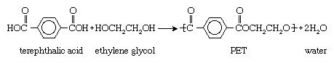

There are many different uses for PET. One of the most common is for drink bottles, including soft drink bottles.

1. List two physical properties of polyethylene terephthalate that make it suitable for use as a container for soft drinks.

(2 marks)

1. What type of polymerisation reaction occurs to form the polymer from the above monomers?

(1 mark)

**Section Three: Extended answer 5 marks**

23. Amides have a significantly higher boiling point than an amines and an alcohol that have similar molar masses.

This is illustrated in the table below.

|  |  |  |  |
| --- | --- | --- | --- |
| Compound type | Example | Molar mass  (g mol-1) | Boiling point  ⁰C |
| Amide | ethanamide | 59.1 | 221.2 |
| Amine | propanamine | 59.1 | 48.5 |
| Alcohol | propanol | 60.1 | 97.2 |

Use the data in the table, and your understanding of intermolecular forces, to infer the type and relative strength of intermolecular forces that occur in these substances.

Explain how you used the data to make your conclusions.

|  |
| --- |
|  |
|  |
|  |
|  |
|  |
|  |
|  |
|  |
|  |
|  |
|  |
|  |
|  |
|  |
|  |
|  |
|  |
|  |
|  |
|  |
|  |
|  |
|  |
|  |
|  |
|  |
|  |
|  |
|  |
|  |
|  |
|  |